**back**

**Overview**

In this lab, we will learn how to perform privilege escalation on a Microsoft Windows machine using the Metasploit UAC bypass module.

**Lab Requirements**

* One virtual install of Kali Linux.
* One virtual Install of Windows 7 Pro.
* An established Meterpreter session with your Windows 7 target.

**Begin the lab!**

Create a meterpreter session between your Kali machine and your Windows 7 Pro target.

From your Kali desktop, right-click on your working folder, and from the context menu,

select **Open Terminal Here**.

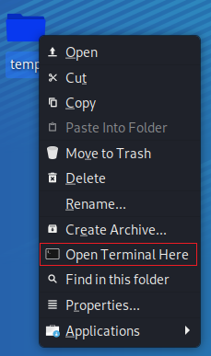

Use your meterpreter script to create a listener. At the terminal prompt, type:

msfconsole -r handler_tcp.rc

If the script completes successfully, your kali should be standing by for communication from your Windows 7 Pro machine when you launch the payload.exe.

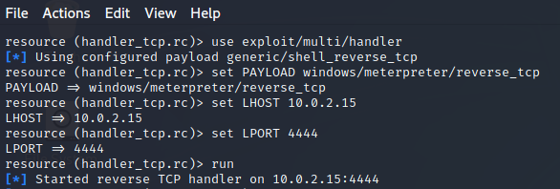

Return to your Windows 7 Pro machine. Open the Documents folder and 2X click the payload.exe file.

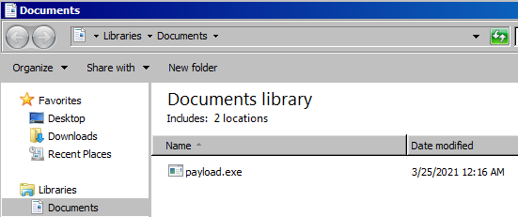

When prompt, click the Run button.

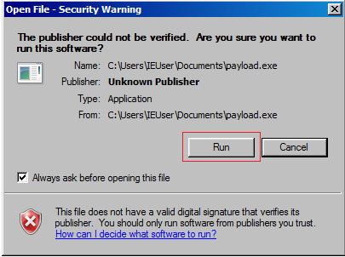

Return to your Kali terminal, and you should see a Meterpreter prompt.

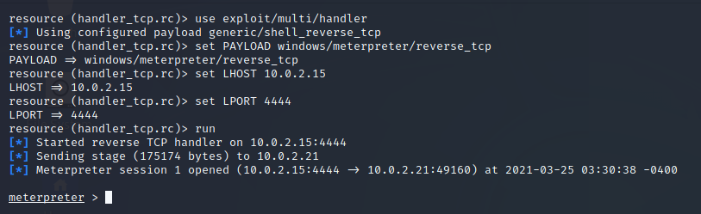

At the Meterpreter prompt, type, **getuid**

The getuid function returns the real user ID of the calling process. We can try and escalate our privileges using the **getsystem** command, but this operation fails as the command is not supported.

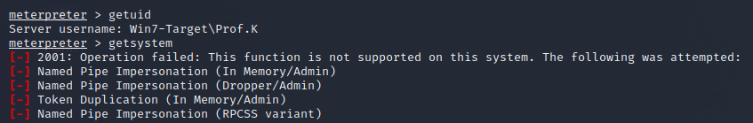

We need to bypass the UAC to get escalated privileges. To do this, we first need to background our current Meterpreter session. We do this by typing **background** at the prompt. Once the session has been background, we need to search for a UAC bypass exploit.



At the prompt, type, **search bypassuac**.

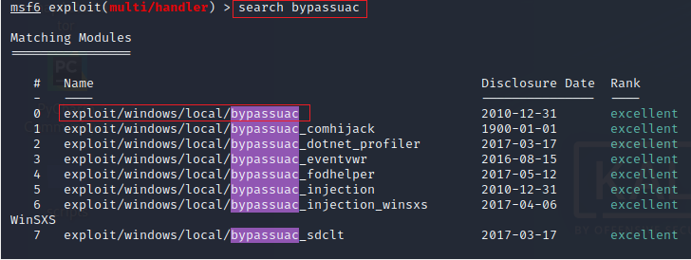

At the prompt type, **use** **exploit/windows/local/bypassuac**

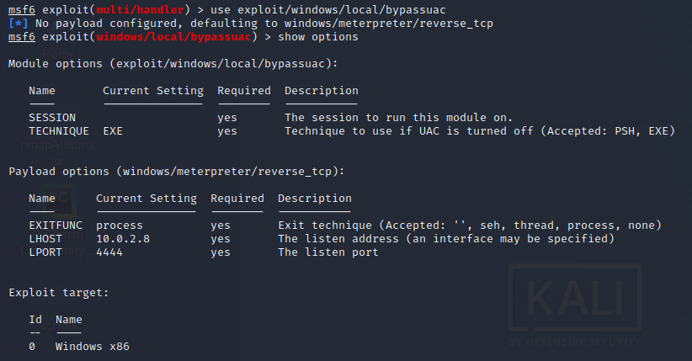

The missing parameter is the session ID. We can list all meterpreter session running using the **sessions -i** command.

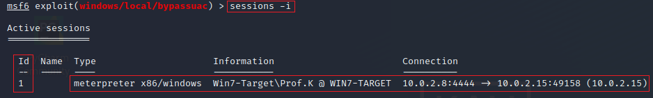

From the results, we know that our Metrepreter session is using the session ID of 1.

We next need to set the SESSION parameter to 1. At the prompt type, **set session 1**.



At the prompt, type run.

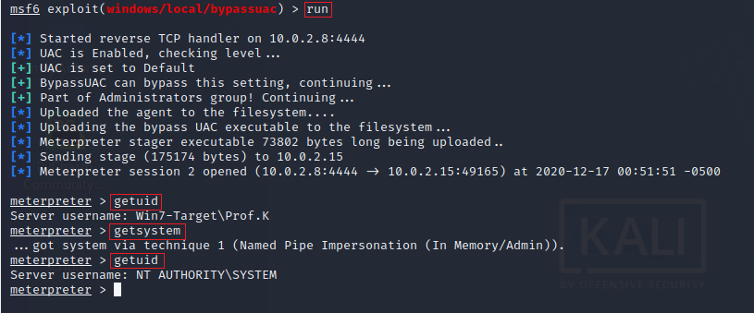

We check the real user ID of the calling process. Now that we have bypassed the UAC, we can escalate our privileges using the **getsystem** command, and we are currently running as NT AUTHORITY\SYSTEM.

Summary –

In this short lab, you learned how to perform privilege escalation using the Metasploit UAC Bypass module.

End of the lab!